Lab Assignment-9

Name: P. Chandra Vardhan Reddy

Hall ticket:2303A51034

Batch-01

Problem 1:

Consider the following Python func on:

def find_max(numbers):

return max(numbers)

Task:

* Write documenta on for the func on in all three formats:
  1. Docstring
  2. Inline comments
  3. Google-style documenta on
* Cri cally compare the three approaches. Discuss the advantages, disadvantages, and suitable use cases of each style.
* Recommend which documenta on style is most effec ve for a mathema cal u li es library and jus fy your answer.

Screenshots:

A:docstring

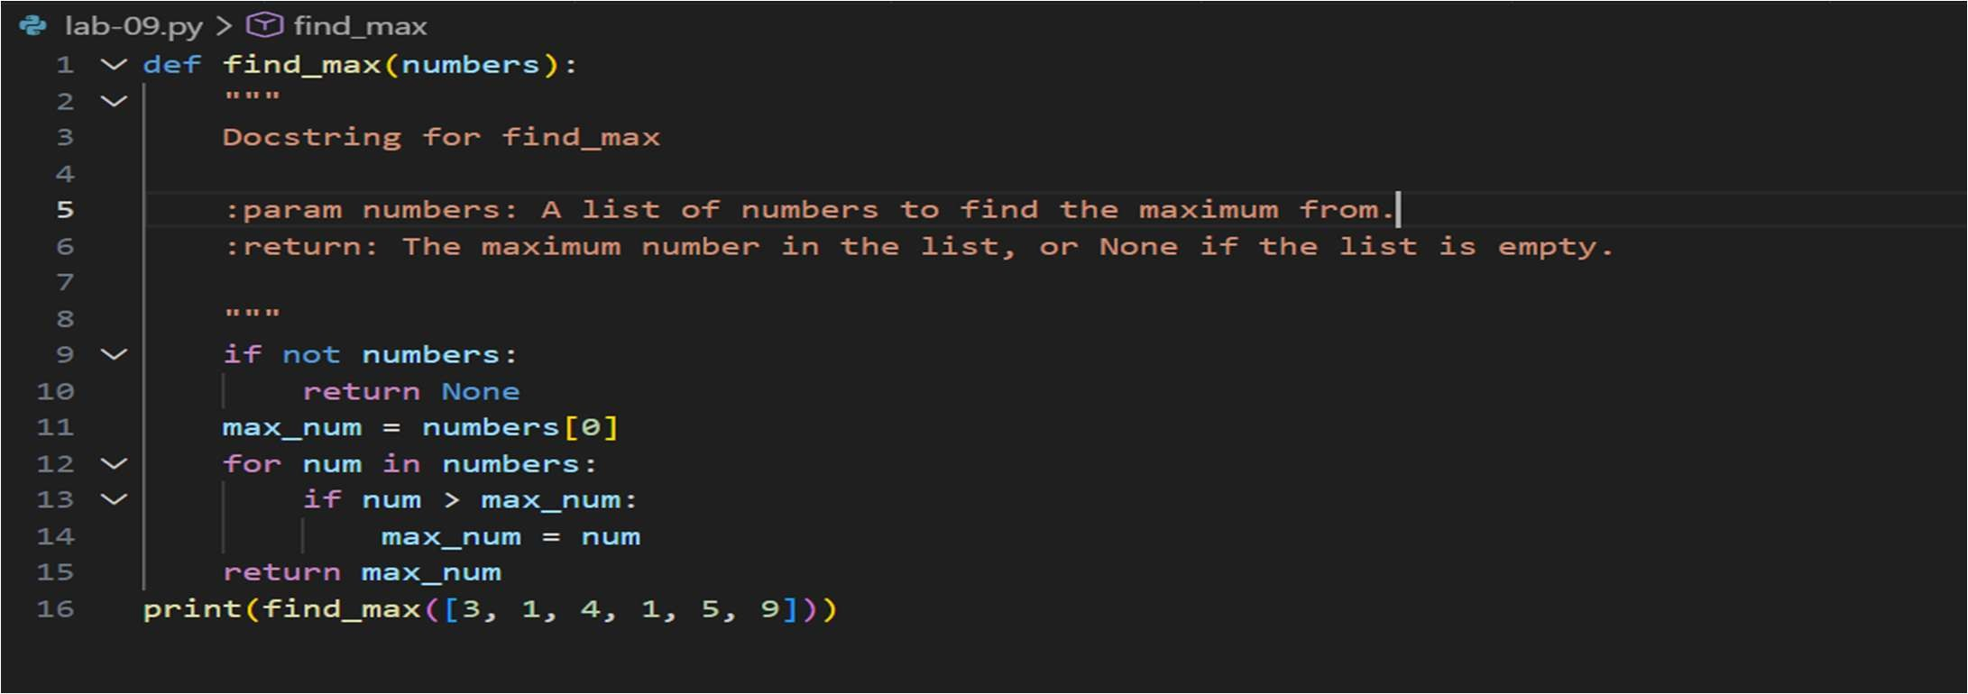

B:in line comments

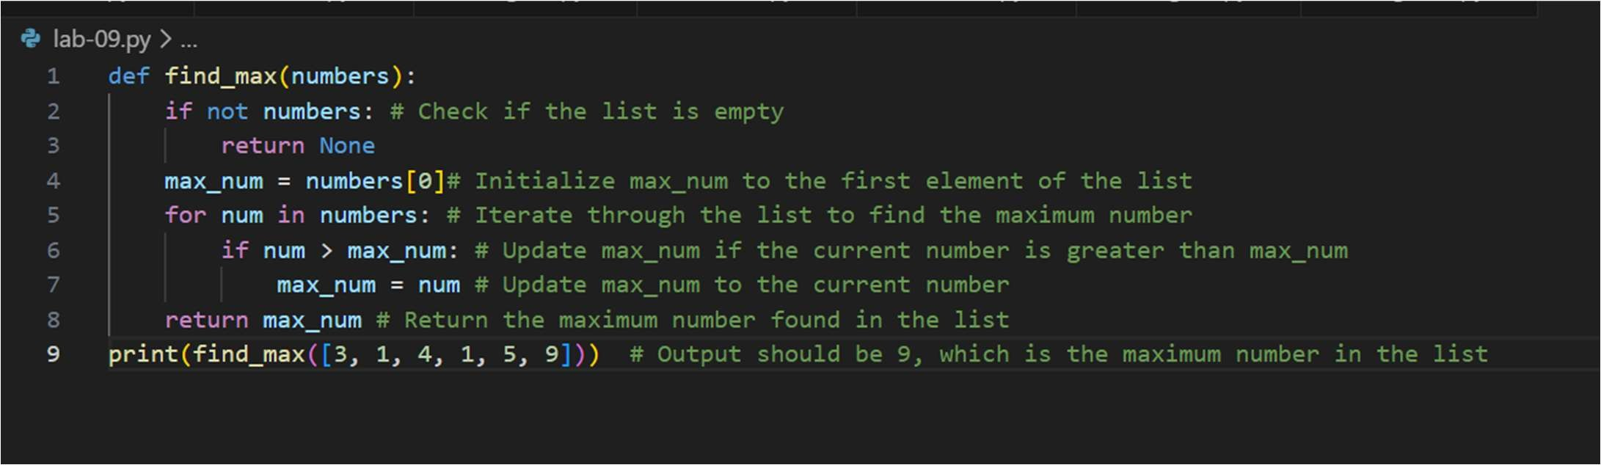

C: Google style

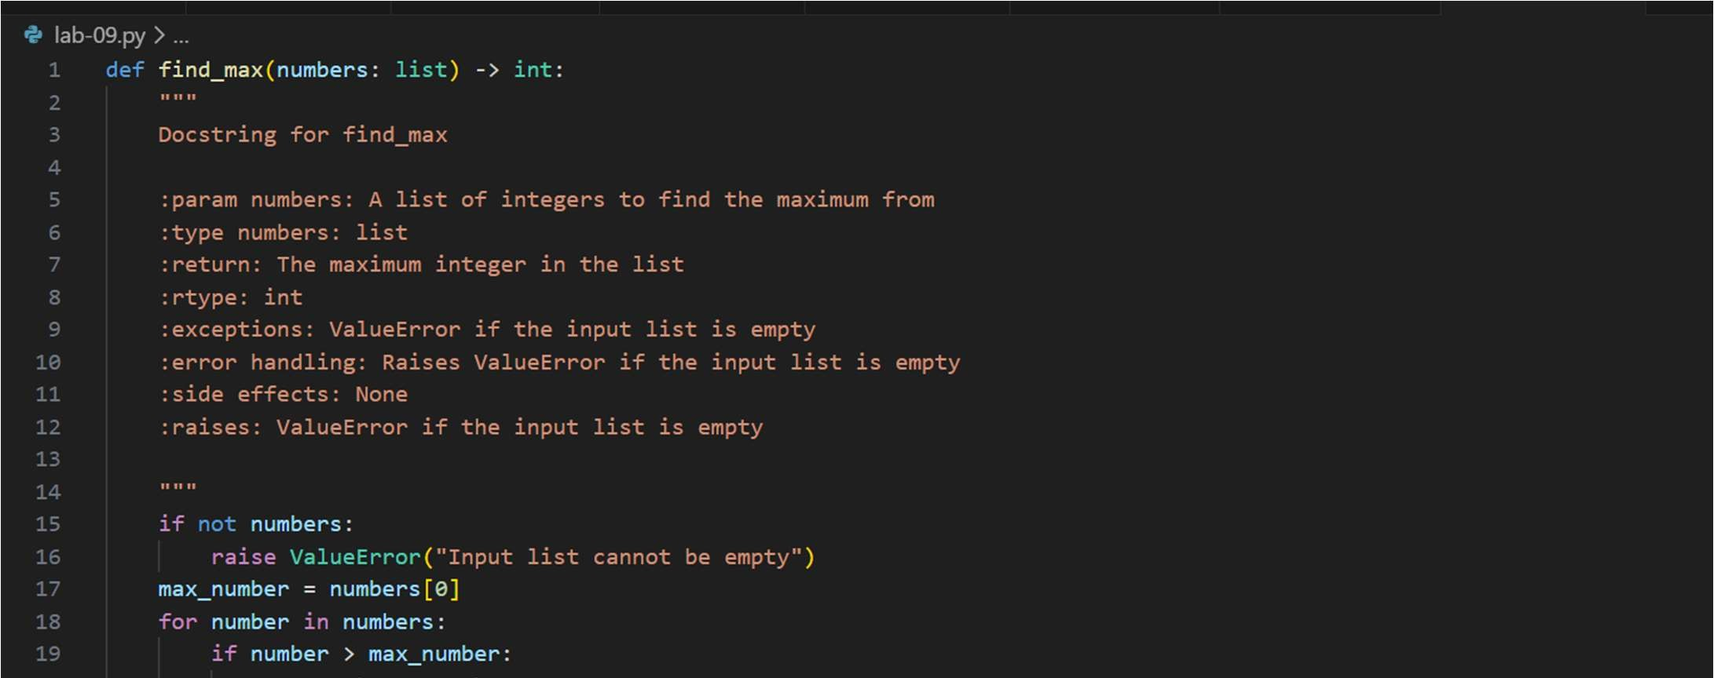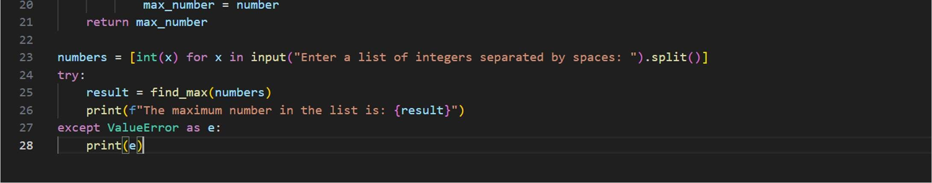

Output:

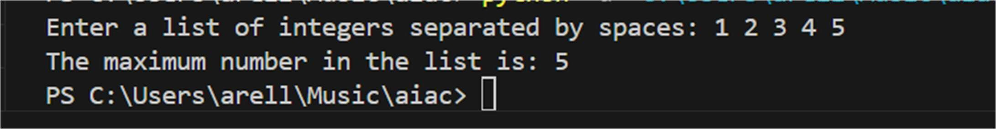

Problem 2: Consider the following Python func on:

def login(user, password, creden als):

return creden als.get(user) == password

Task:

1. Write documenta on in all three formats.
2. Cri cally compare the approaches.
3. Recommend which style would be most helpful for new developers onboarding a project, and jus fy your choice.

A:docstring:

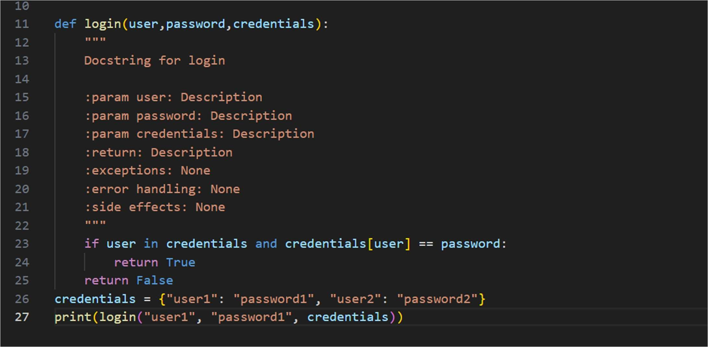

B: google style

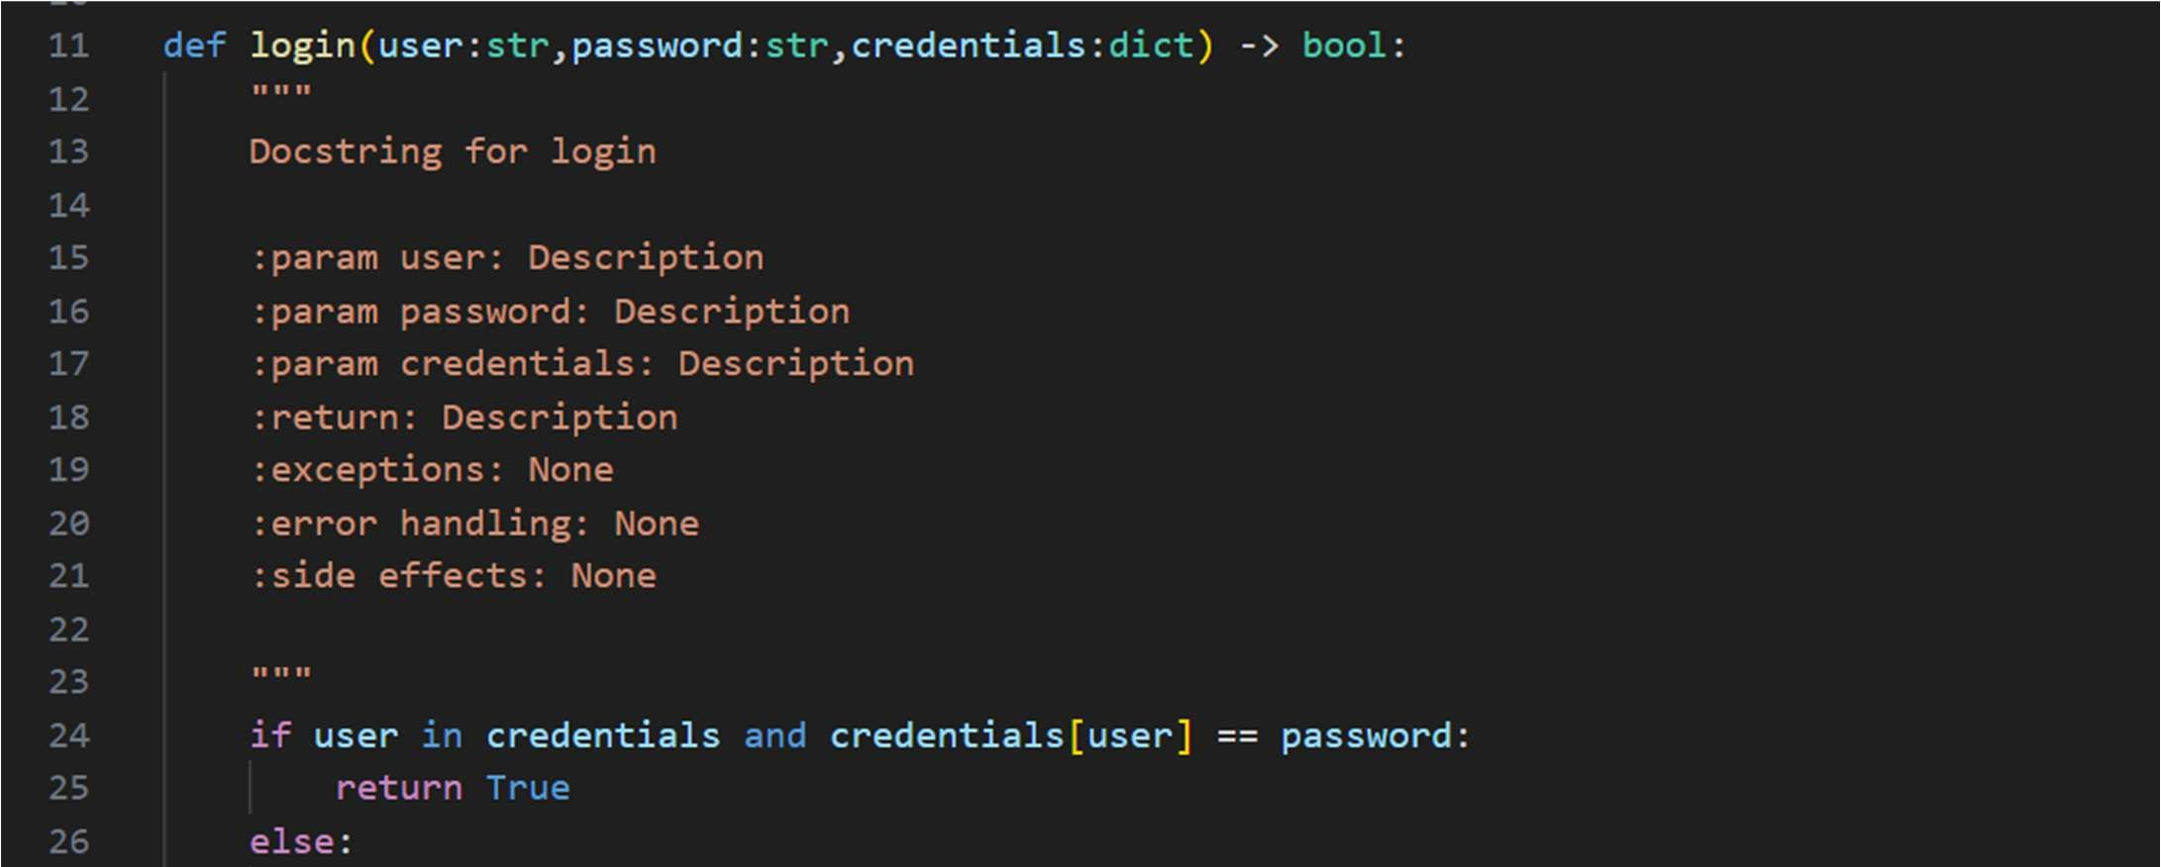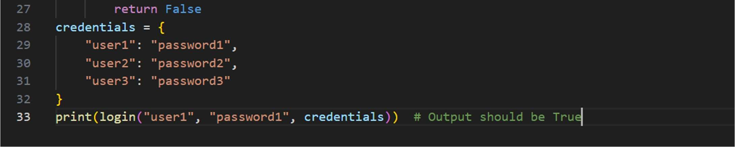

C:Inline comments

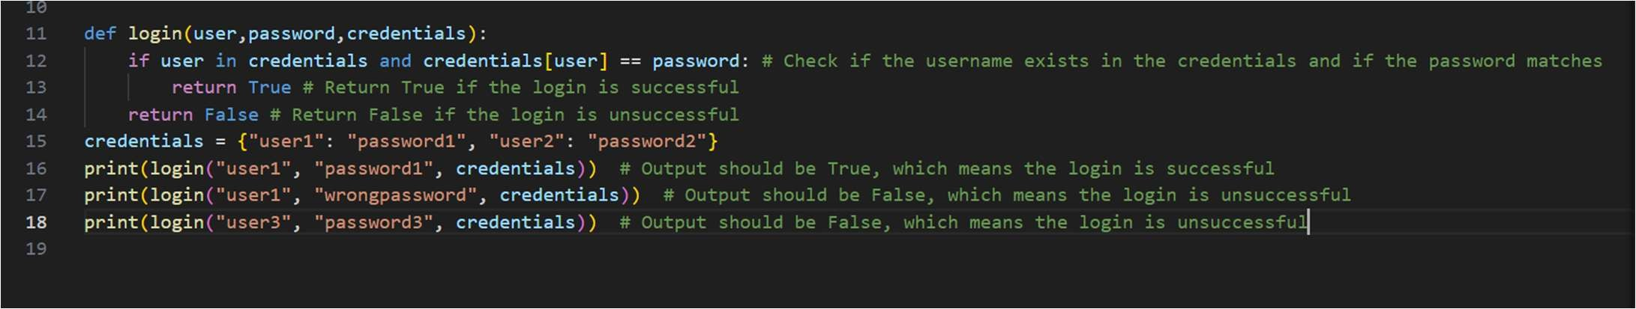

Output:

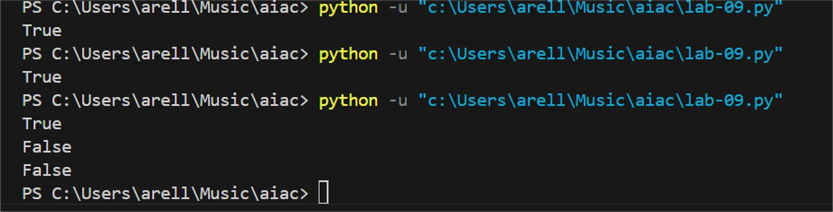

Problem 3: Calculator (Automa c Documenta on Genera on) Task: Design a Python module named calculator.py and demonstrate automa c documenta on genera on.

Instruc ons:

1. Create a Python module calculator.py that includes the following func ons, each wri en with appropriate docstrings:

o add(a, b) – returns the sum of two numbers o subtract(a, b) – returns the difference of two numbers o mul ply(a, b) – returns the product of two numbers o divide(a, b) – returns the quo ent of two numbers

1. Display the module documenta on in the terminal using Python’s documenta on tools.
2. Generate and export the module documenta on in HTML format using the pydoc u lity, and open the generated HTML file in a web browser to verify the output.

Screenshots:

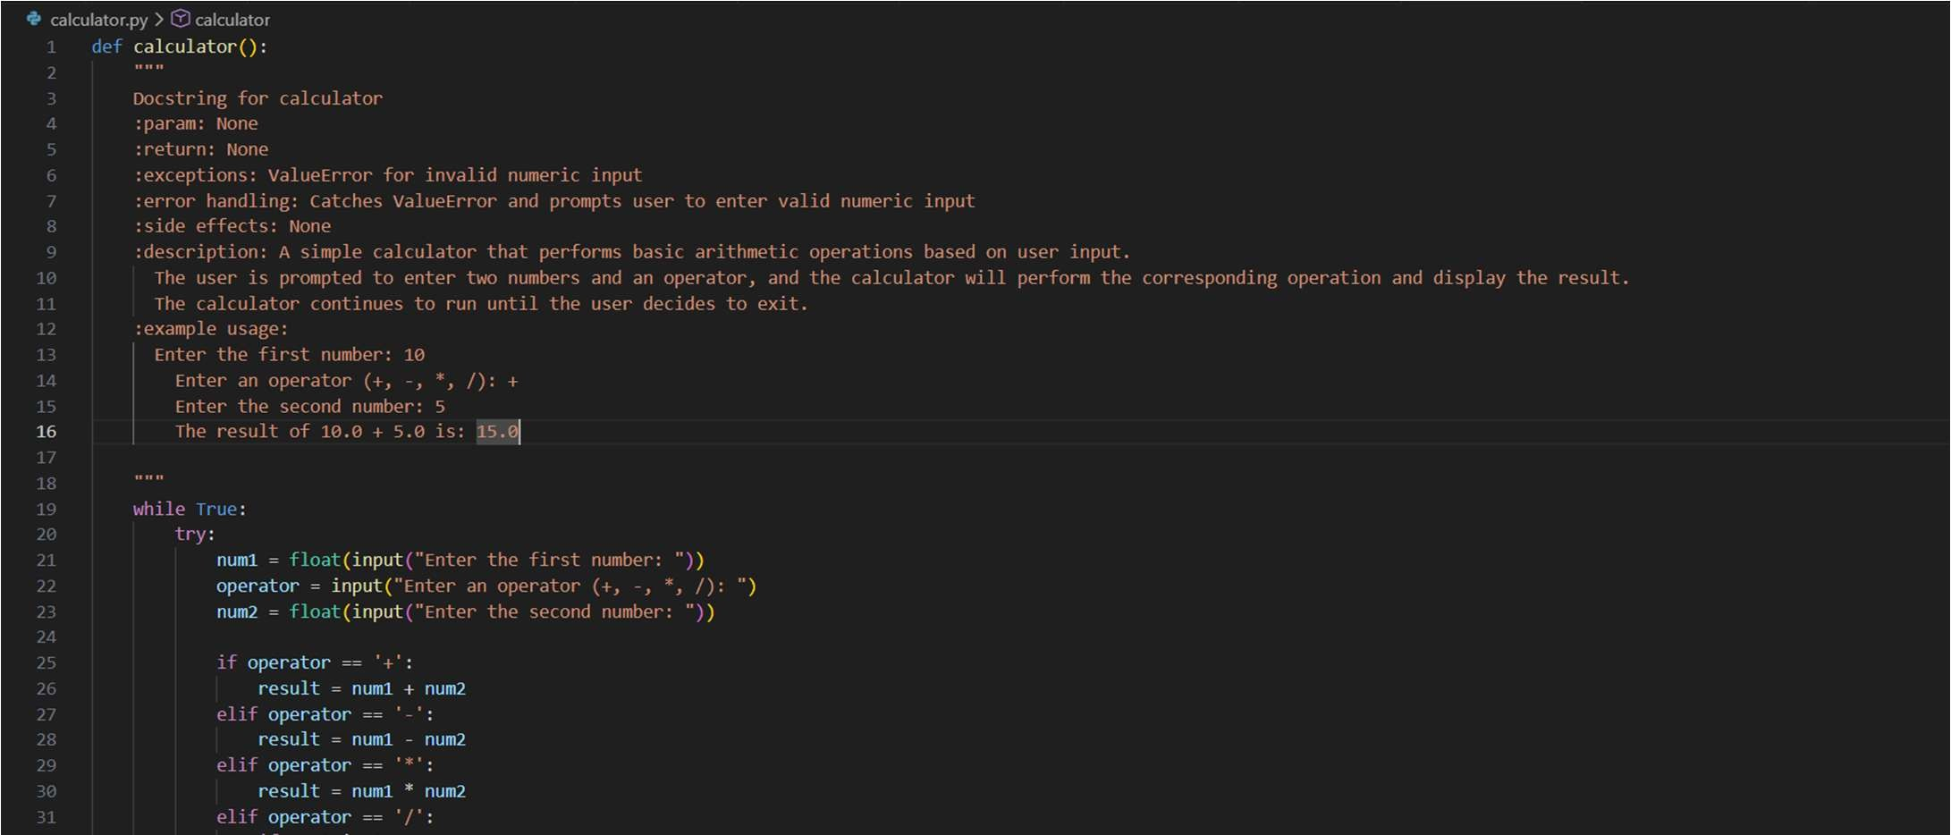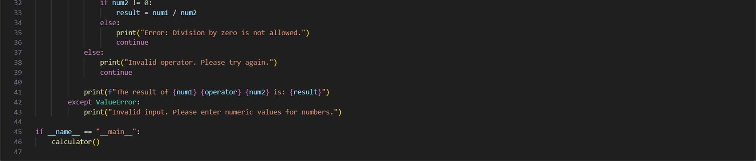

Output:

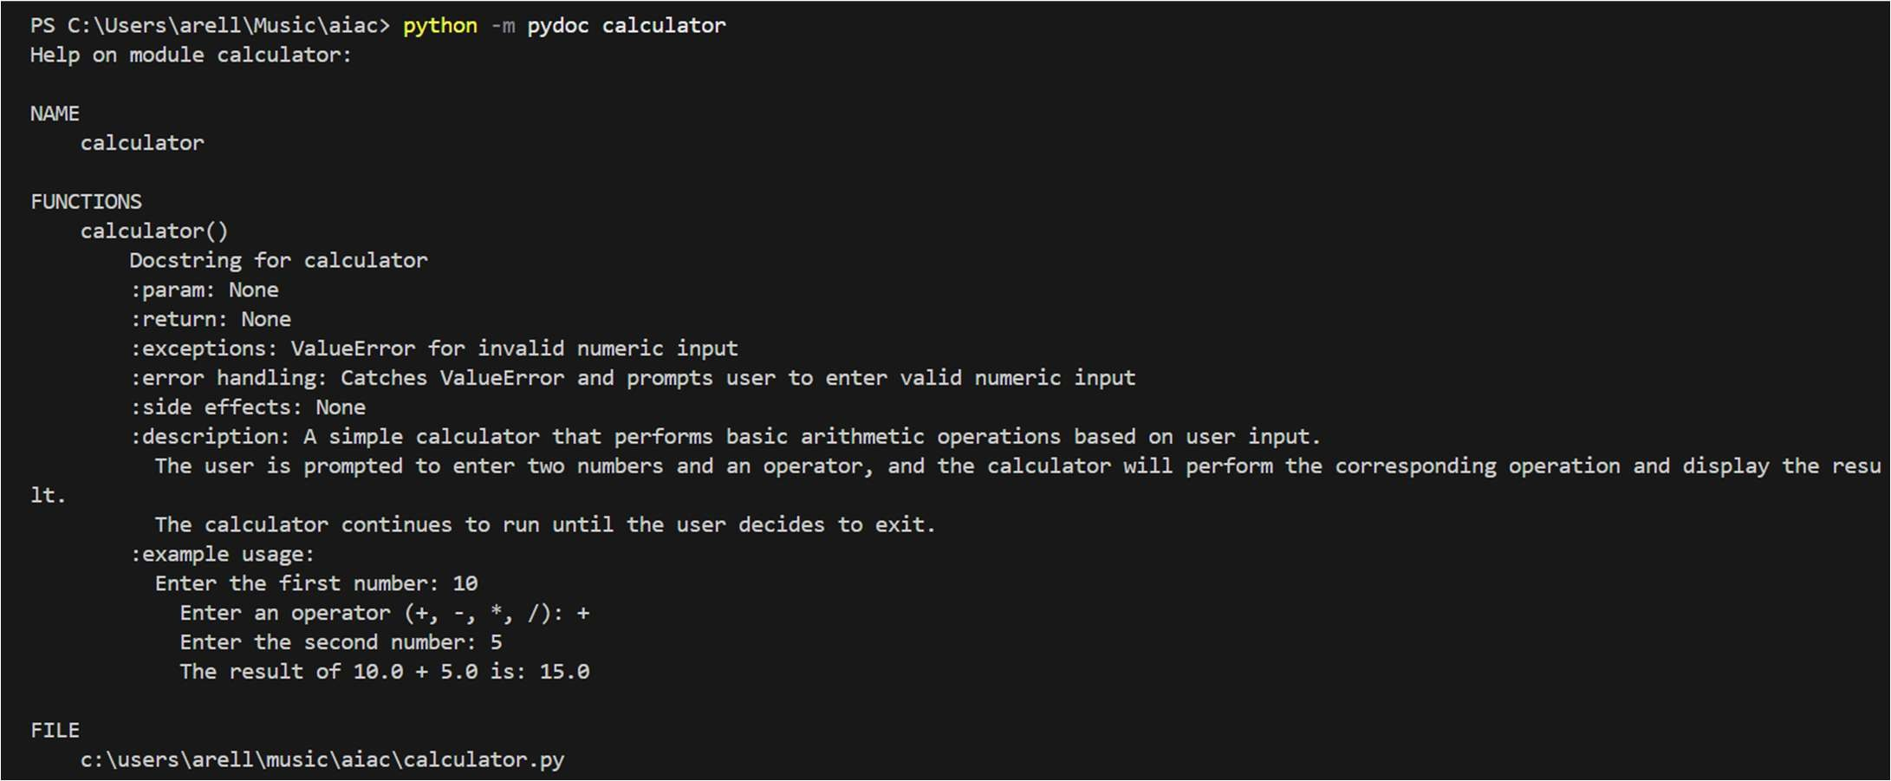

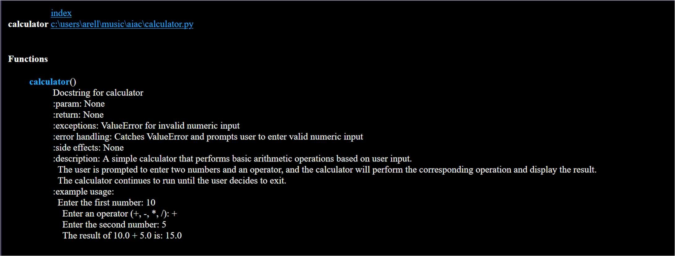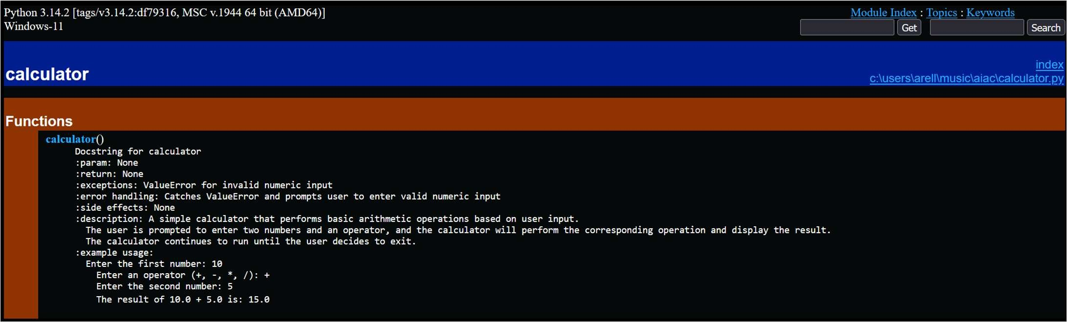

Problem 4: Conversion U li es Module

Task:

1. Write a module named conversion.py with func ons:

o decimal_to_binary(n) o binary_to_decimal(b) o decimal_to_hexadecimal(n) 2. Use Copilot for auto-genera ng docstrings.

1. Generate documenta on in the terminal.
2. Export the documenta on in HTML format and open it in a browser.

Screenshots:

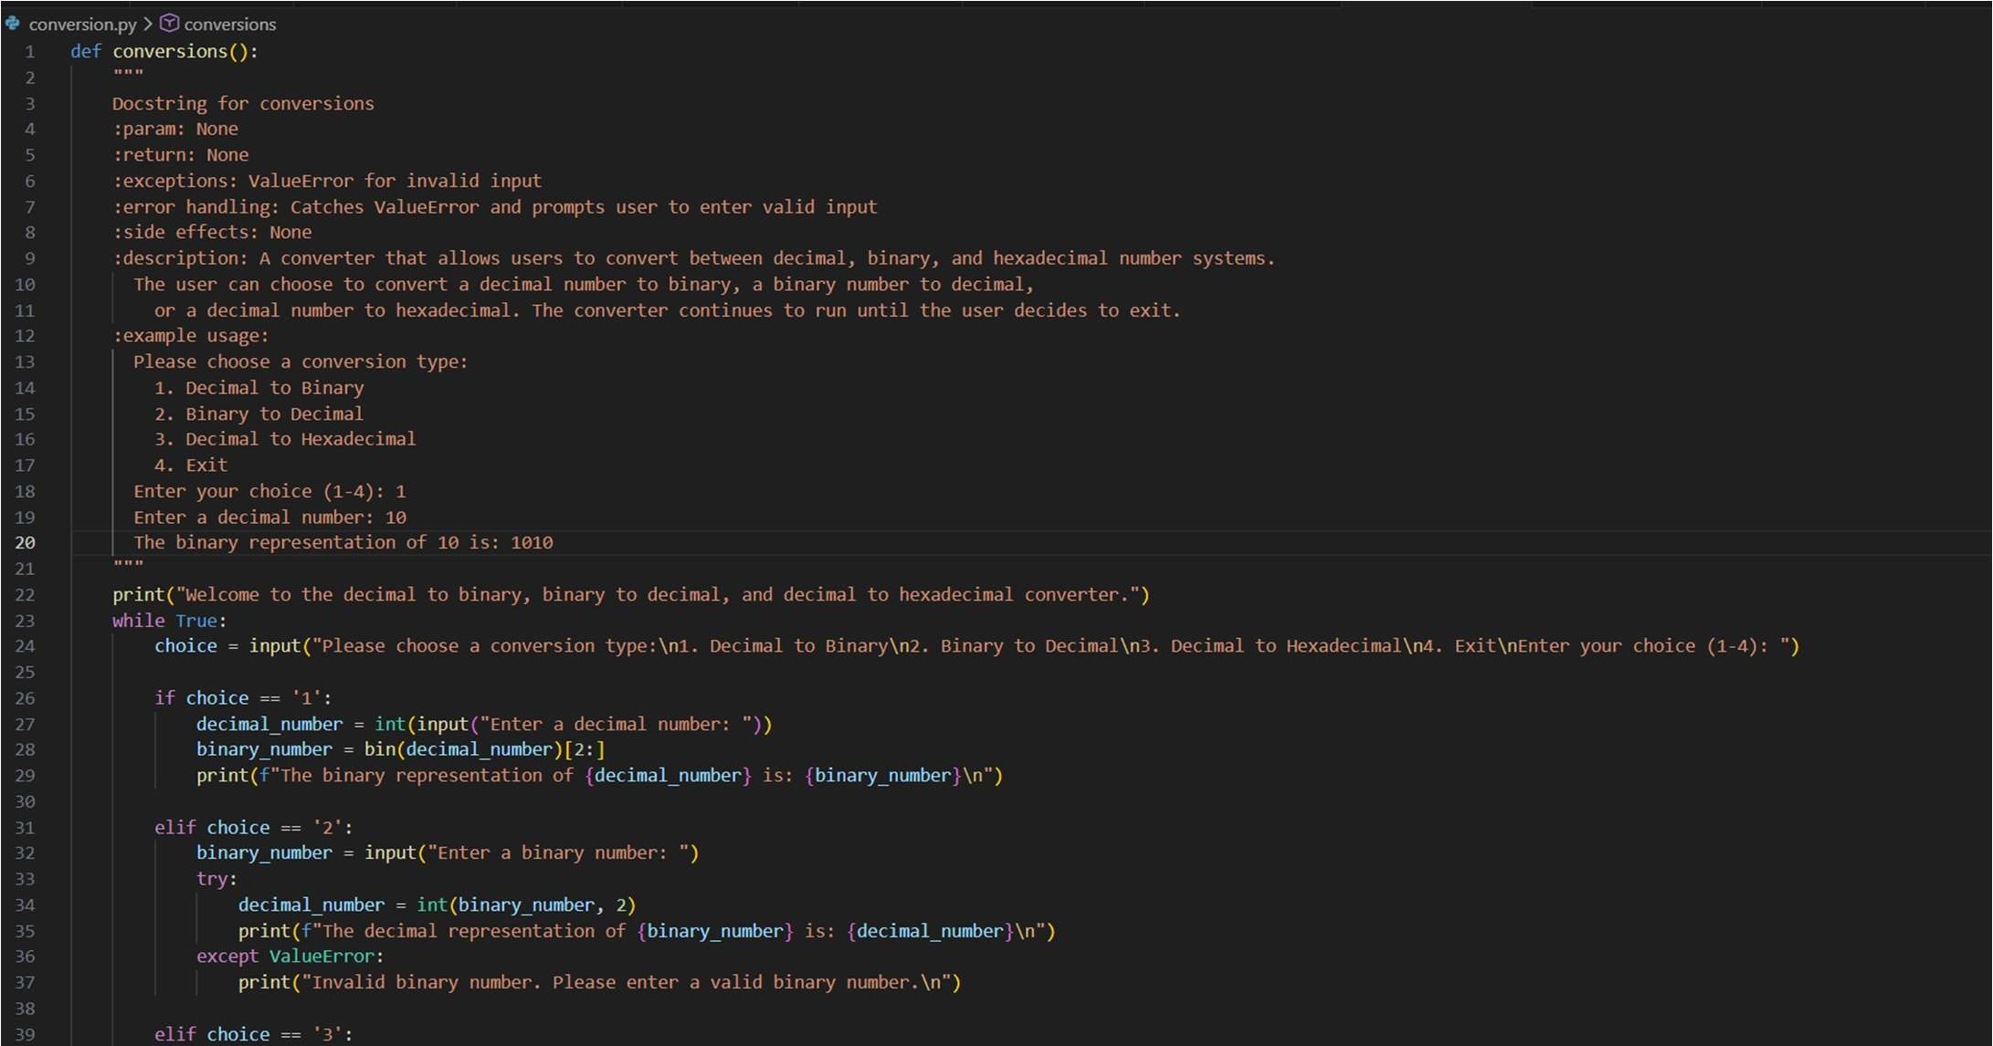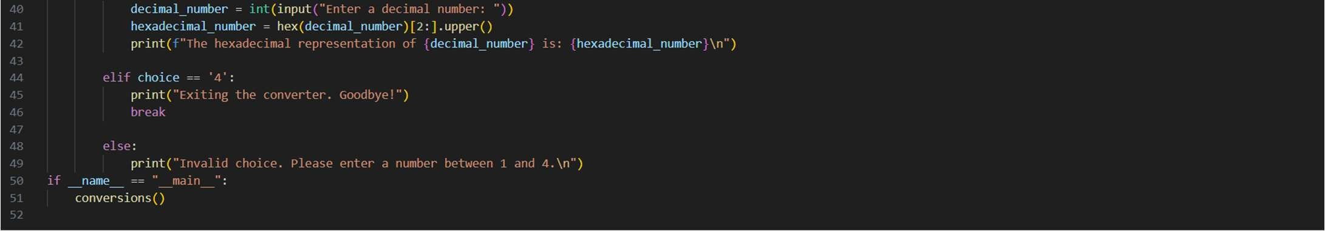

Output:

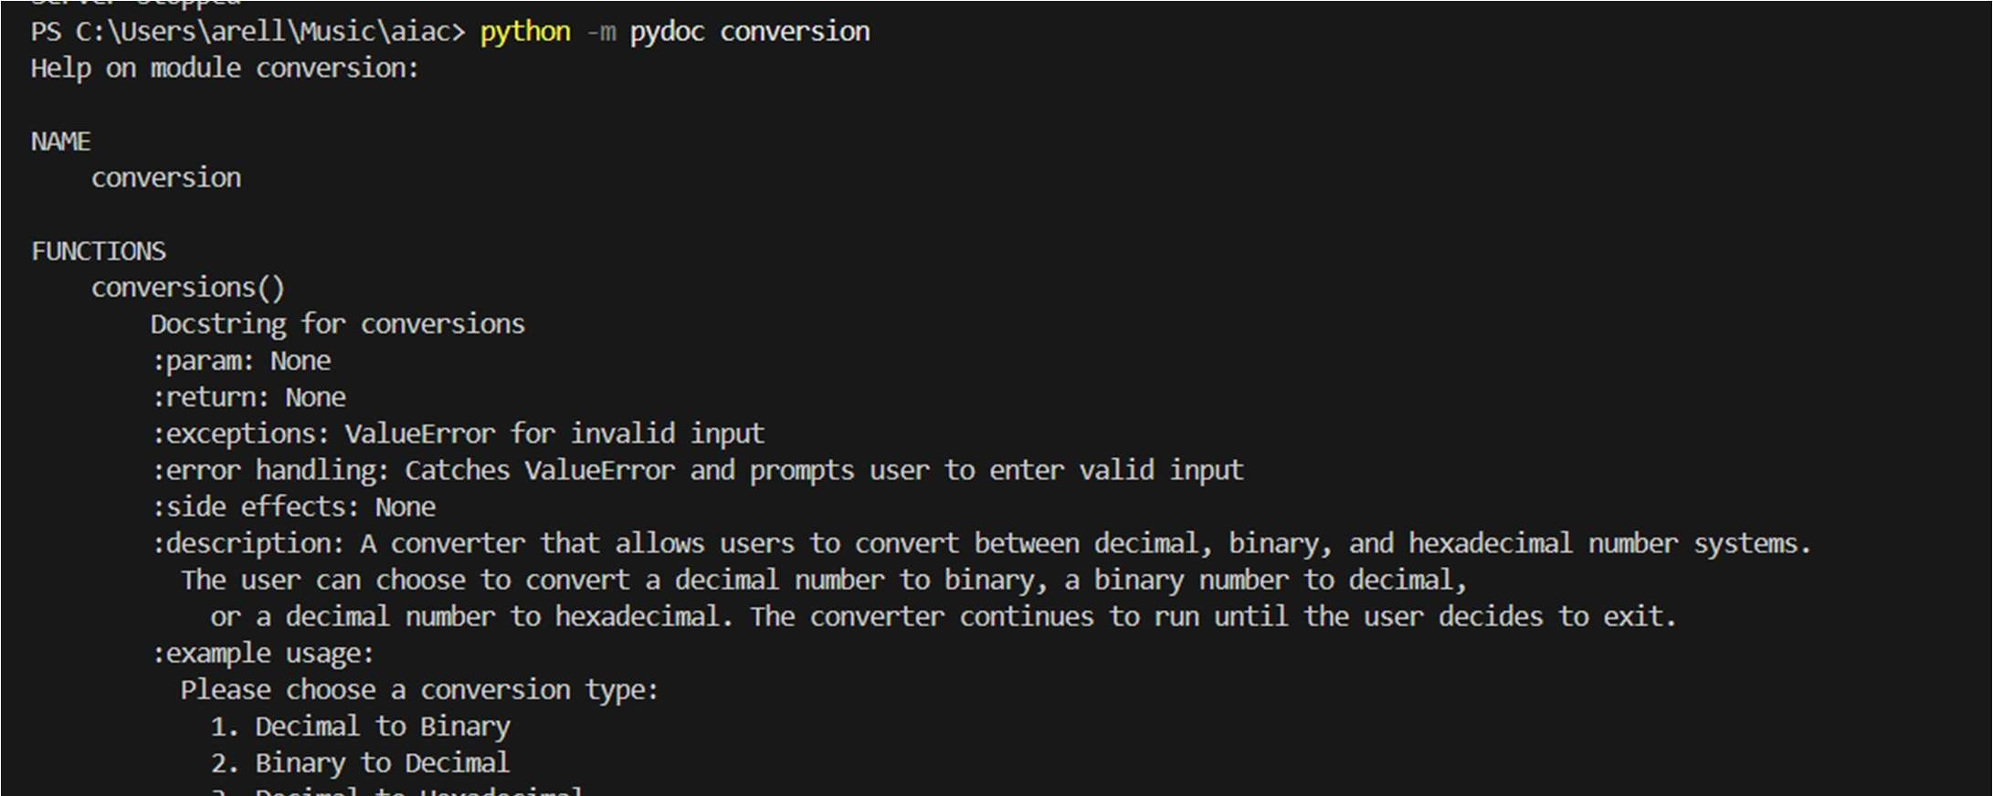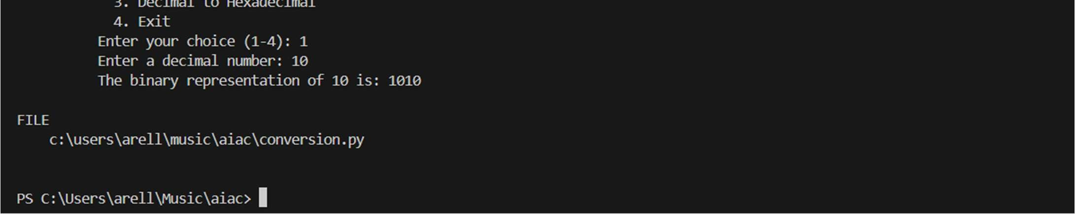

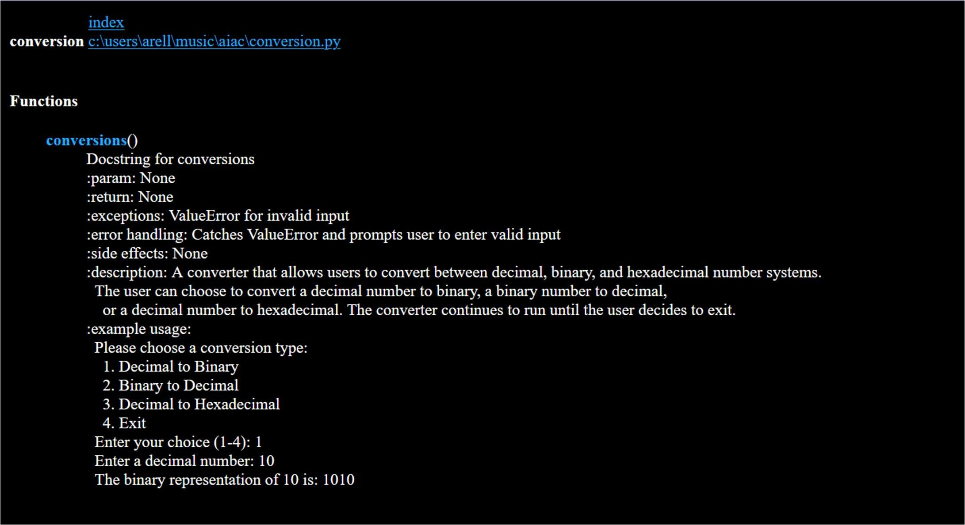

Problem 5 – Course Management Module

Task:

1. Create a module course.py with func ons:

o add_course(course_id, name, credits) o remove_course(course_id) o get_course(course_id)

1. Add docstrings with Copilot.
2. Generate documenta on in the terminal.
3. Export the documenta on in HTML format and open it in a browser.

Screenshots:

